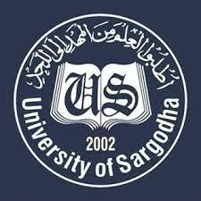 |  | Faculty Positions on Visiting Basis
 |  | Department of Information Management (formerly Library & Information Sciences)
Applications for the following positions are invited from Pakistani Nationals for fall 2022 & spring semester 2023.
Teaching Faculty
Sr# | Positions |  | No. of  Posts | Nature of Post | Eligibility Criteria
1. | Visiting Assistant Professor |  | 02-04 | Visiting Faculty  (Open Merit) | Qualifications: PhD in LIS/IM
2. | Visiting Lecturer |  | 04-06 | Visiting Faculty  (Open Merit) | Qualifications: M.Phil. in LIS/IM
NOTE |  | General Information
- As per University Policy, the University reserves the right not to consider any application or fill any post without giving any reason.
- Candidates are required to submit complete CV and attested copies of testimonials along with duly filled application form in the office of the Department.
- Prescribed application form may be downloaded from the University website. (http://www.su.edu.pk)
- Applications complete in all respects should reach the institute on or before 29 August, 2022.
- Interview of the short-listed candidates will be conducted on 31 August 2022 (at 11:00 am) in the office of Chairman, Department of Information Management, Sargodha University.
- The government employees meeting eligibility criteria may apply through proper channels for teaching during duty hours.
- Only short-listed candidates will be called for interview.
- Applications received after due date will not be entertained.
- Candidates with relevant experience will be preferred.
- Seats can be increased or decreased according to the requirement of subjects.
- Applications be addressed to Chairman, Department of Information Management, University of Sargodha.
- Online applications will not be accepted.

Chairman
Department of Information Management (formerly Library and Information Sciences) University of Sargodha

